**Name: Jesnamol Thomas**

**Roll No:6**

**Batch:B**

**Date:24/03/2022**

**NETWORKING & SYSTEM ADMINISTRATION LAB**

**Experiment No.: 1**

**Aim**

Familarization of linux commad.

**Procedure**

1. **pwd :** The [pwd](https://www.javatpoint.com/linux-pwd) command is used to display the location of the current working

directory.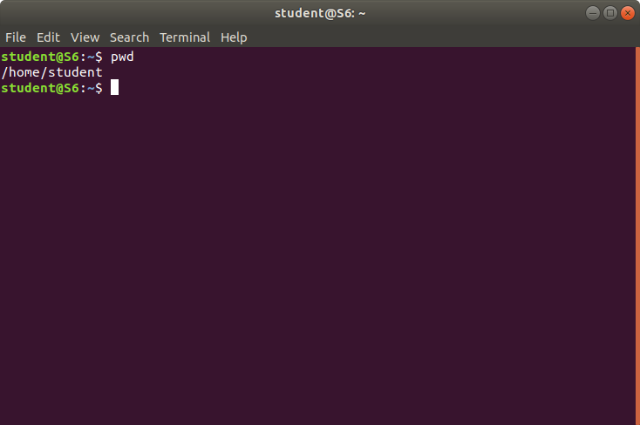

1. **mkdir** **:** The [mkdir](https://www.javatpoint.com/linux-mkdir) command is used to create a new directory under any

directory.



1. **ls** **:** This command is used to display list of a content of a directory,

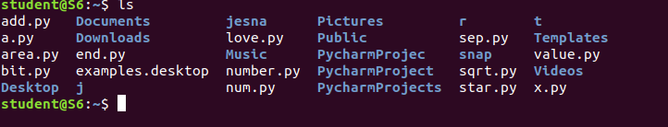

1. **man ls** **:**  It provides a detailed view of the commands

1. **ls -l** **:** It is used to list information about files and directories within the file

system.

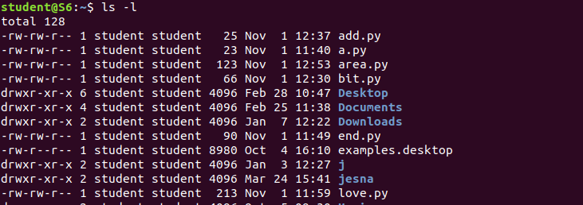

1. **ls –r** : It is used for showing sub directories.



1. **ls –a** **:** List all files including hidden files starting with ‘.’also.



1. **ls –al :** It will list all files and all directories.

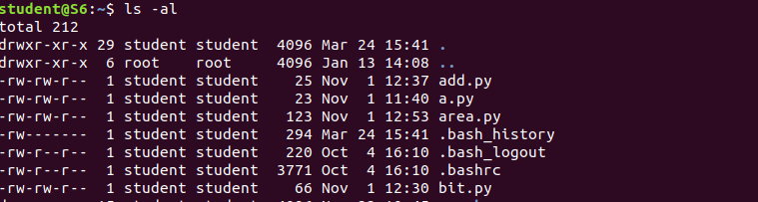

1. **Ls –t :** It show all list of files in last modified order.



1. **cd :** This command is used to change the current working directory .



1. **cd ..** : Refers to the directory immediately above the current directory, its

parent directory.



1. **cd -** :To change to the previous directory from the current working directory.



**13**.**cat >filename:**To create new file.



**14.cat filename:**For viewing the file.

**15.cat >>filename:**For adding additional info to that file.

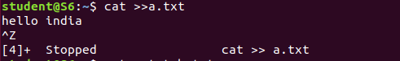

**16.cat file1>file2:**To copy the content of one file to another file.

